**Analysis of algorithm’s efficiency**

**Dataset-1**

Difficult to differentiate some previously already annotated images

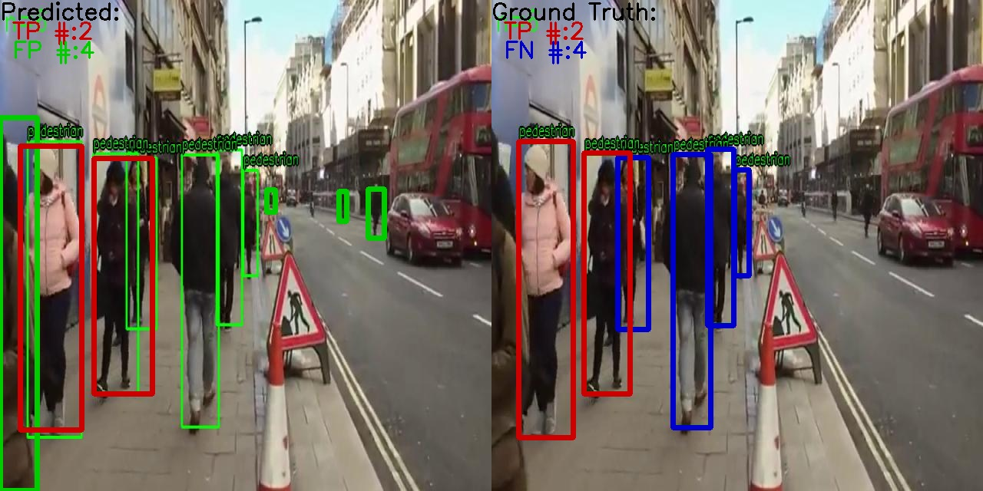

One case, when the model falsely considered a stand as a human even if it is not a human on the stand

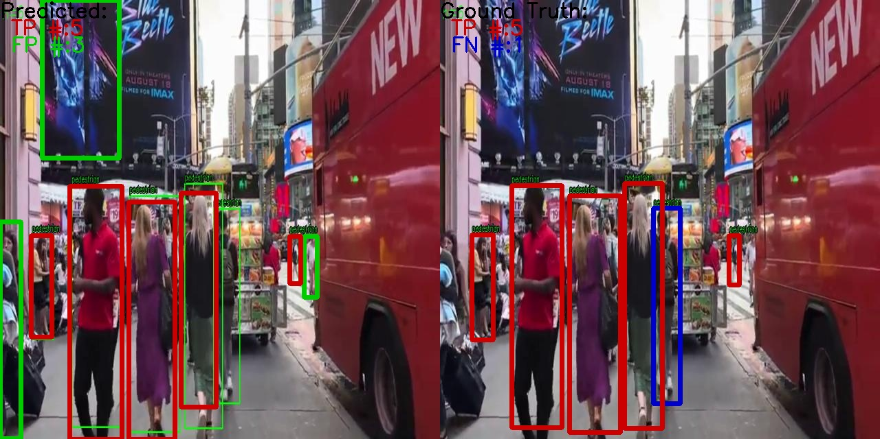

Mostly it could greatly classify images

**Dataset-2**

The model is more likely to classify each person in a crowd

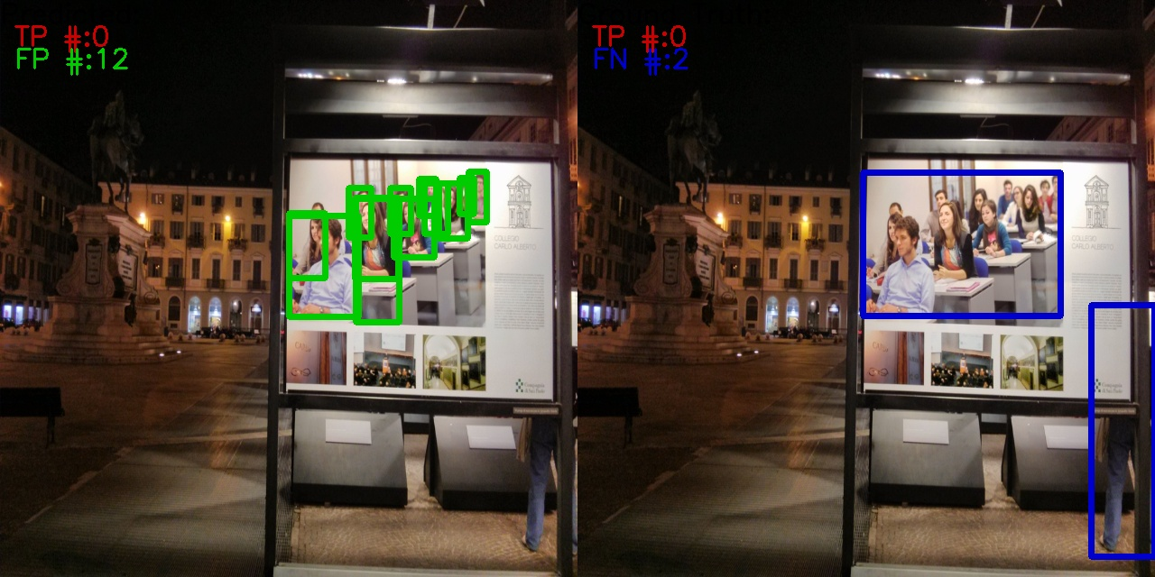

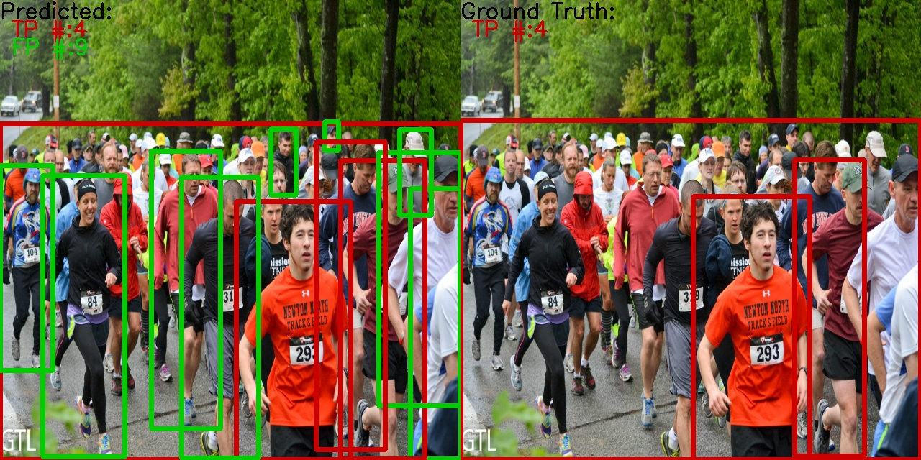

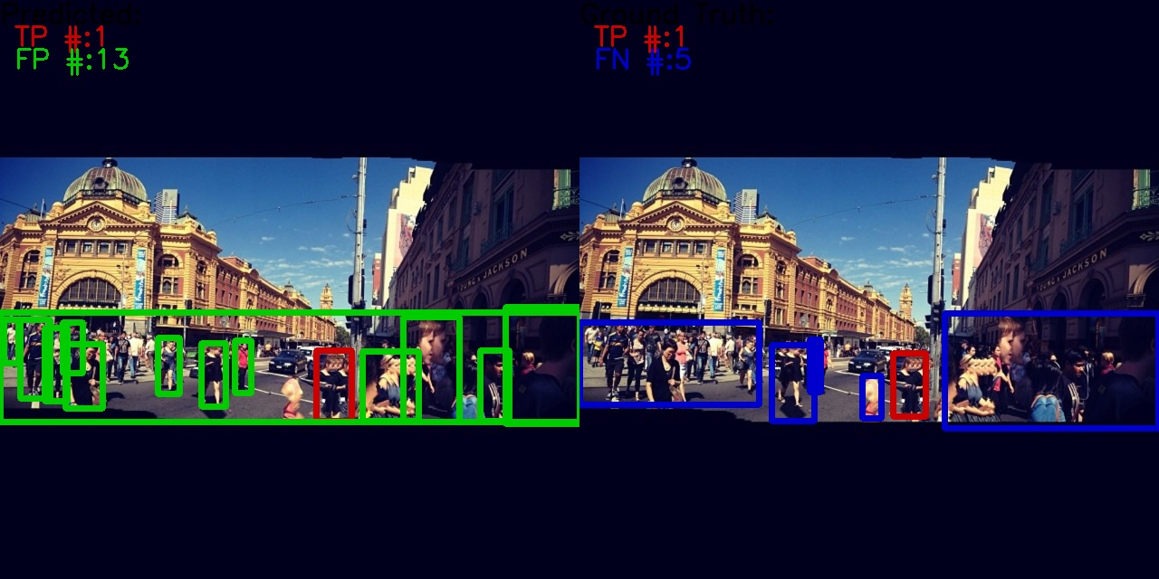

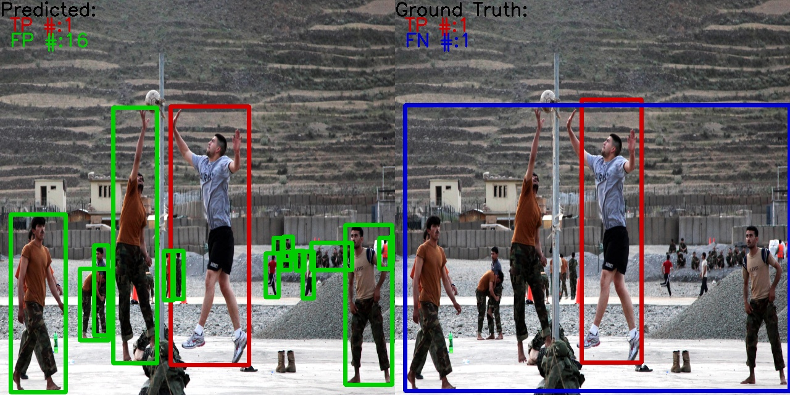

The model can confuse statues or images as humans:

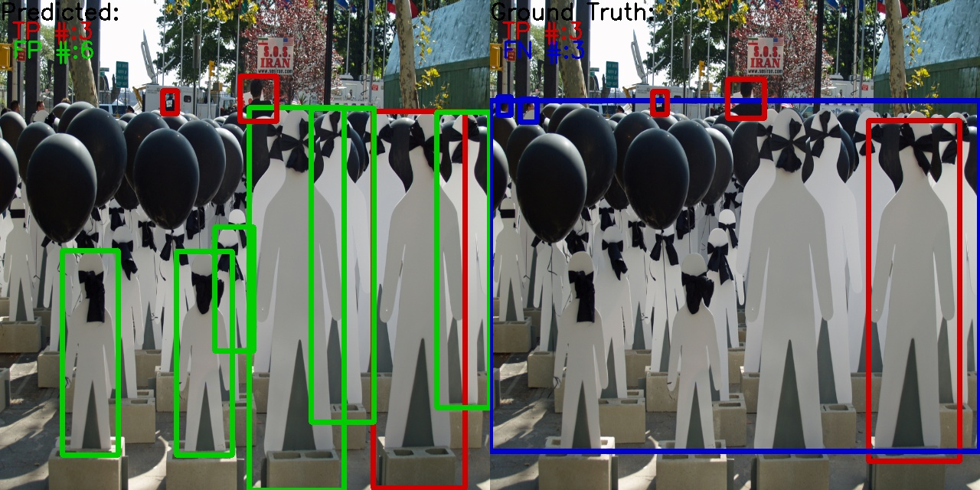

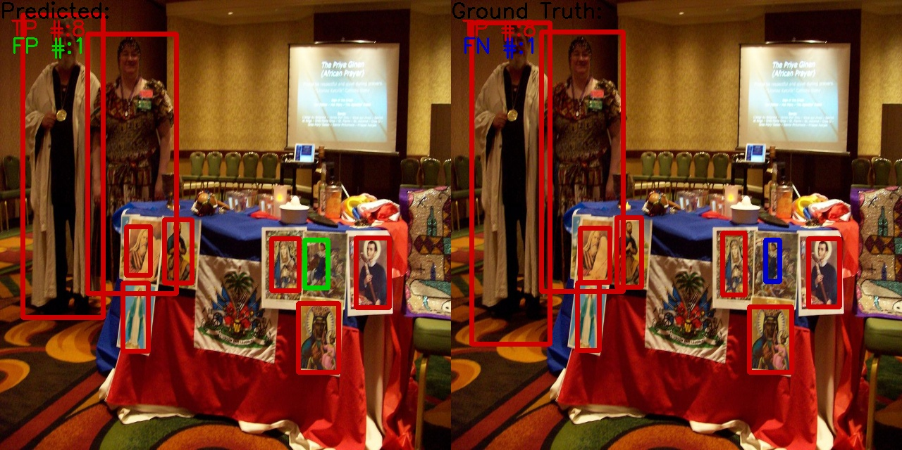

In plants, it shows good results:

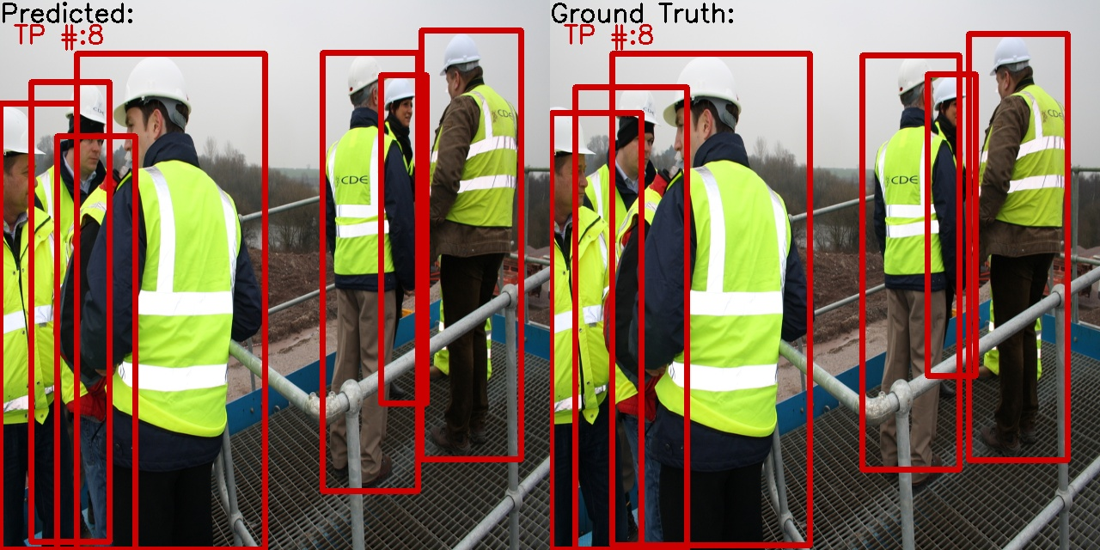

It is less likely to classify a crowd as one human. It is often cause by a large distance between the crowd and human, bad lighting or obstacle:

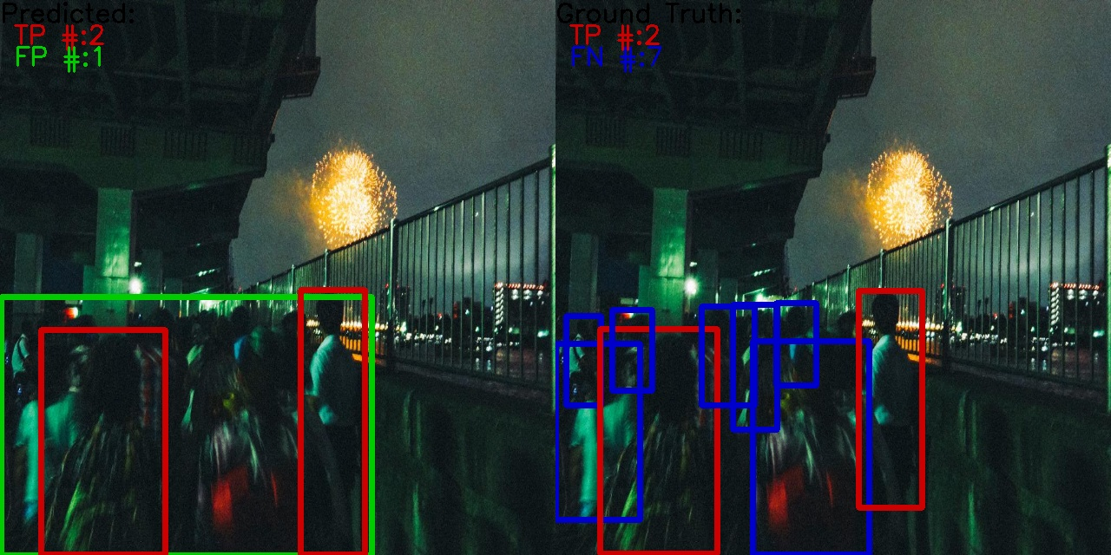

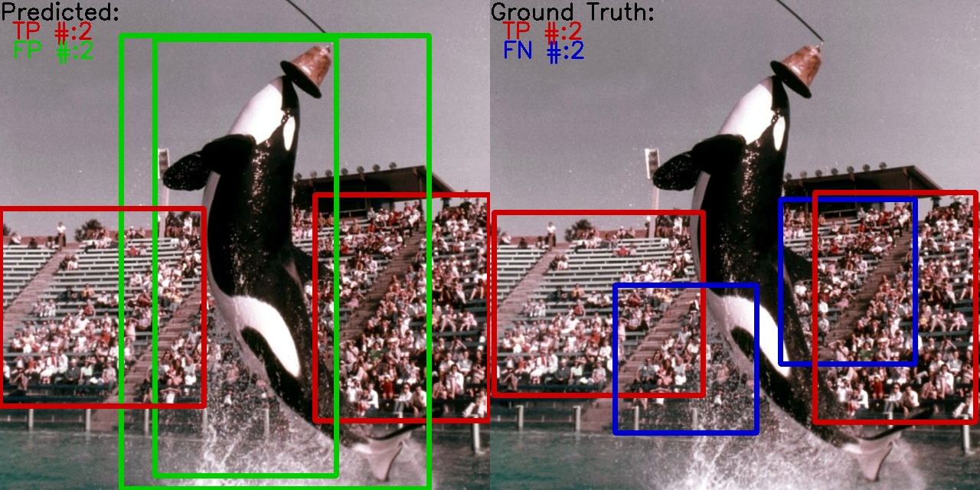

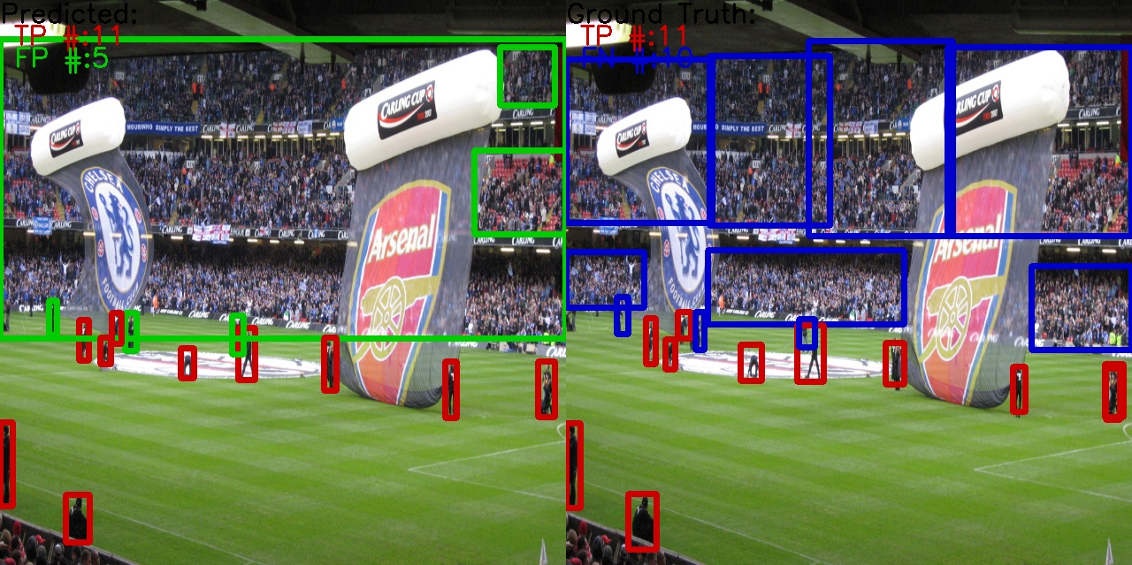

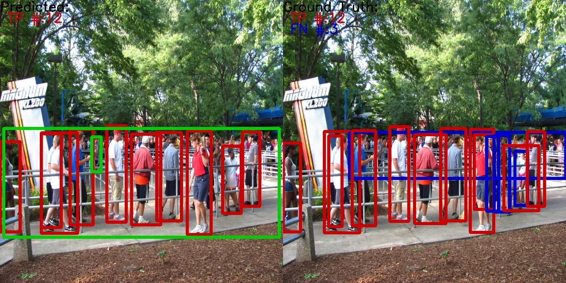

The model considers human shadows as humans themselves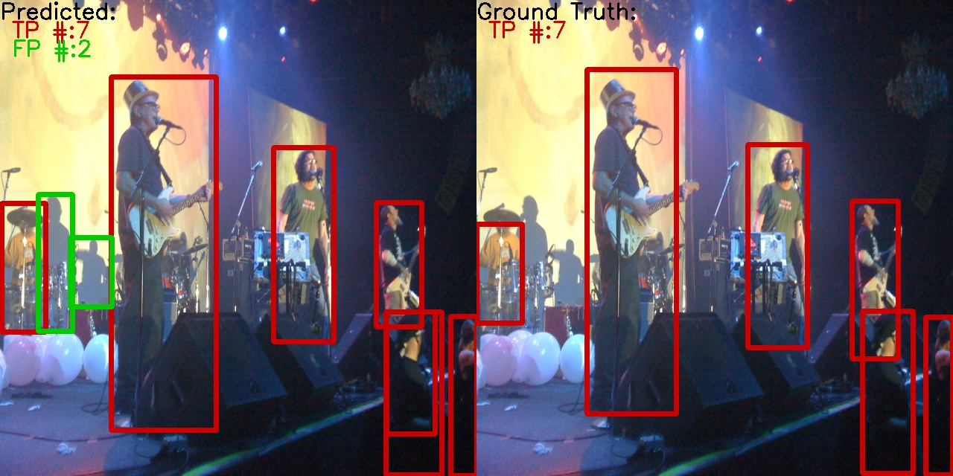

The model considered a brand as a human

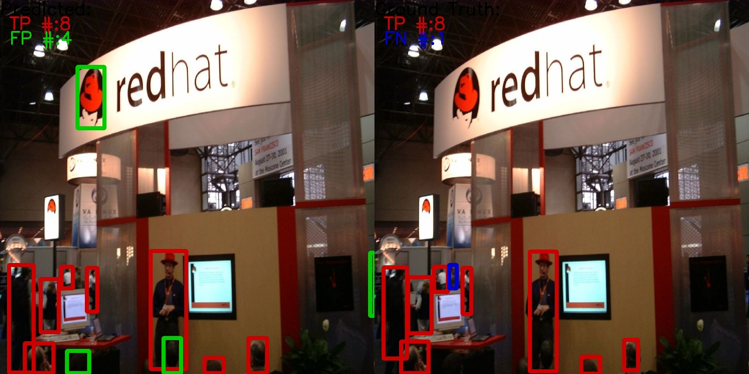

The model considered animals as humans

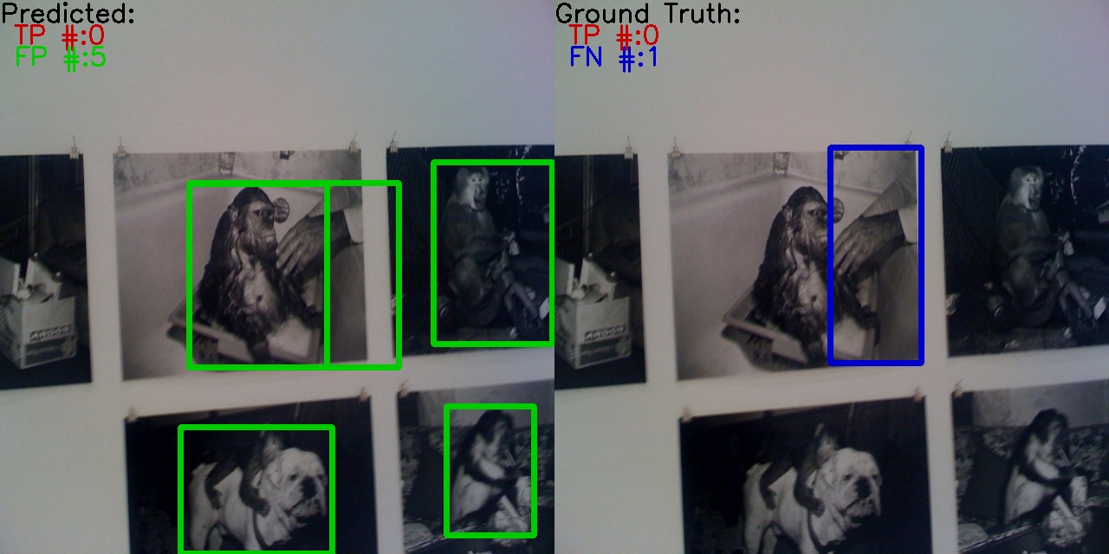



The model considered cartoons as humans

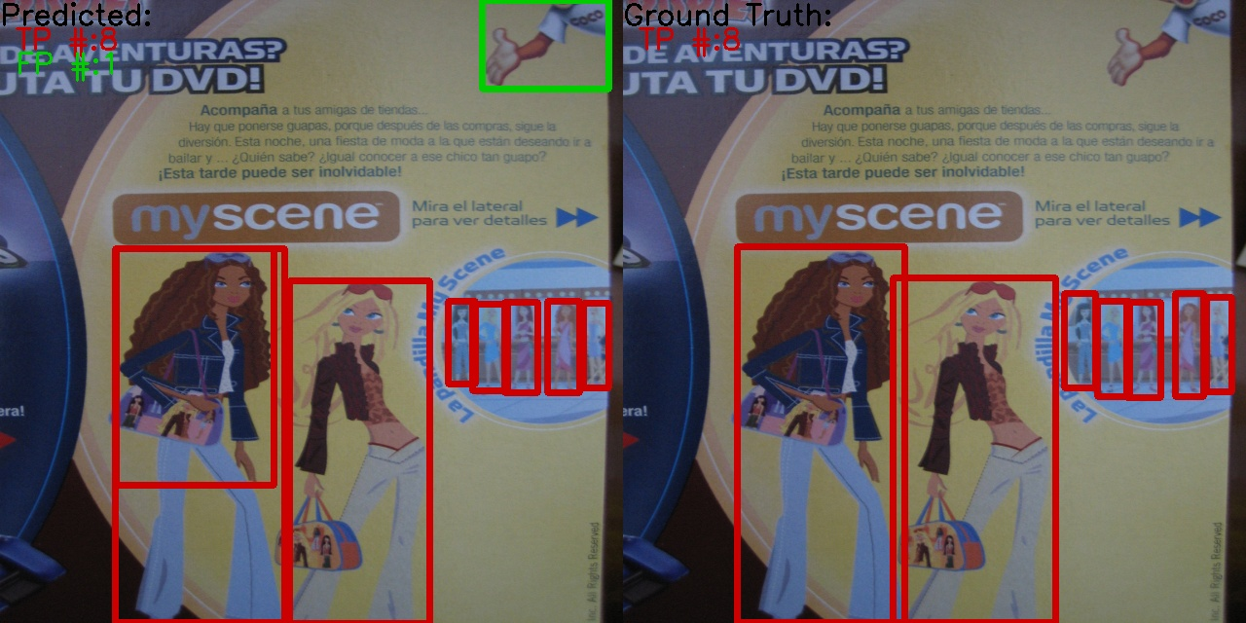

The model considered dolls as humans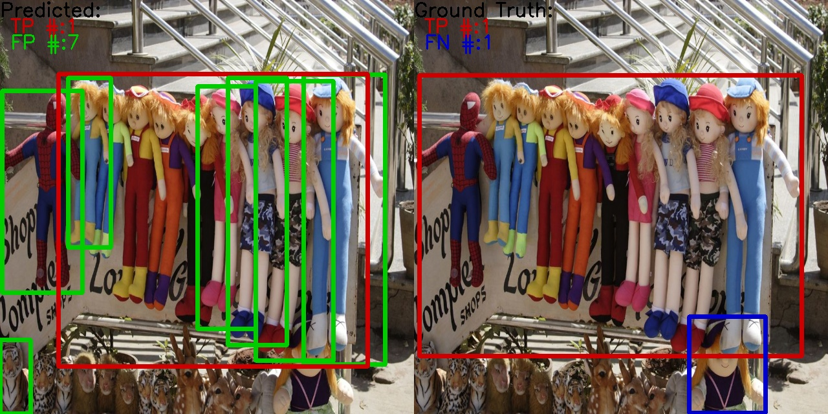

**Dataset-3**

The model has difficulty to differentiate black men with black clothes

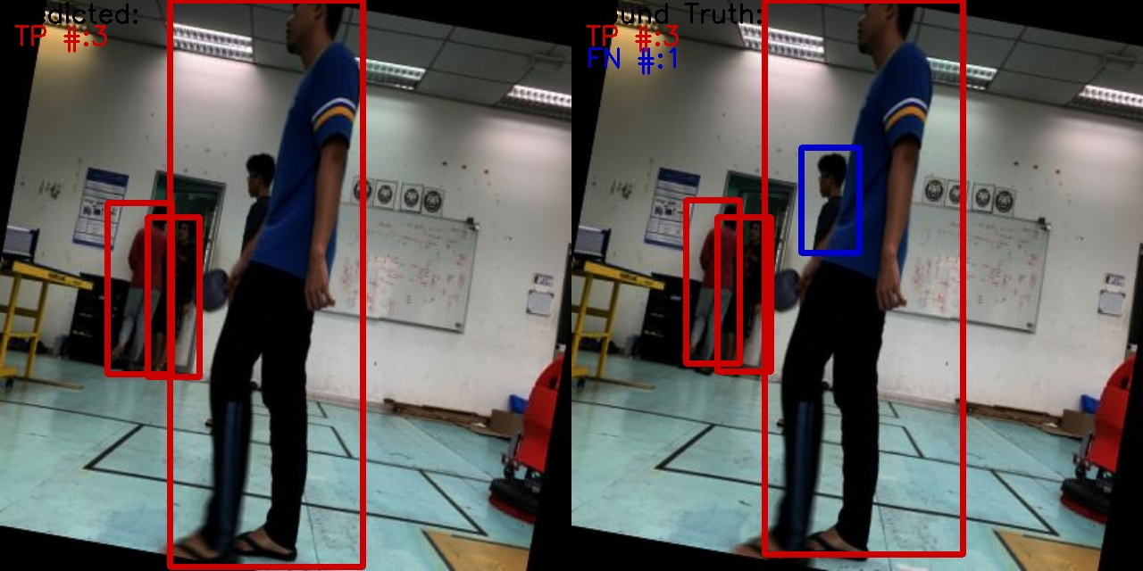

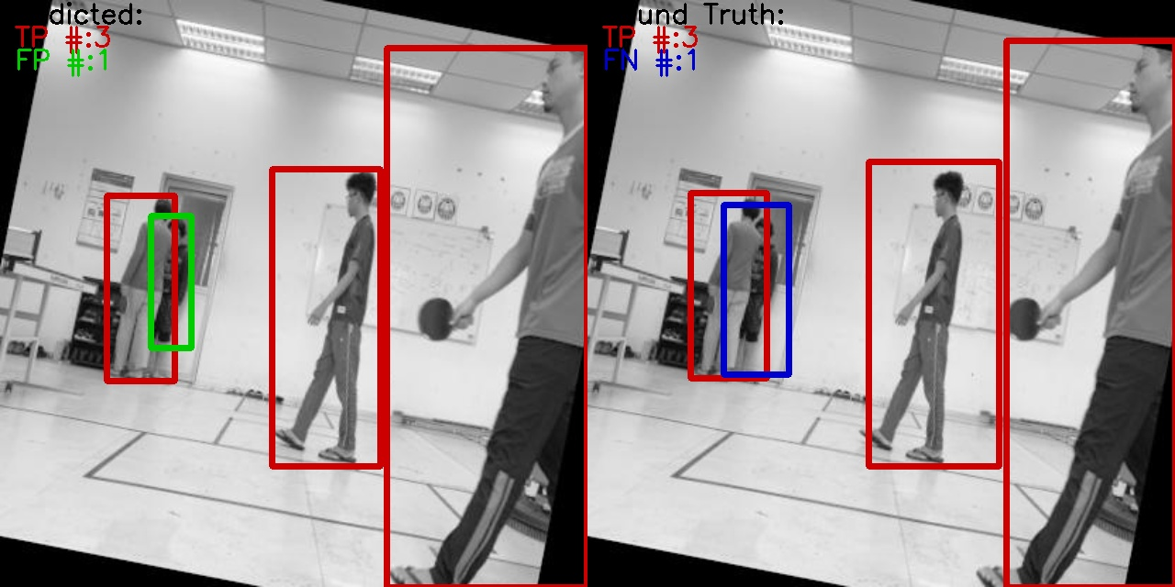

**Dataset-4**

Due to obstacles, the model can label one human 2 times

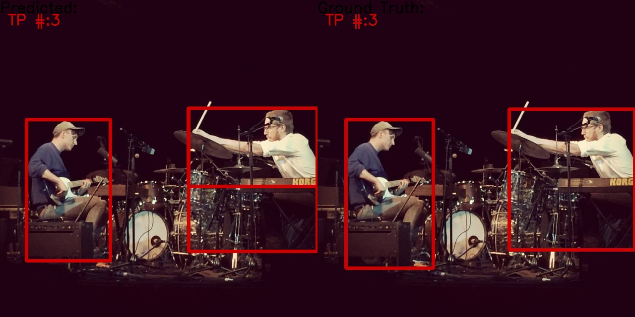

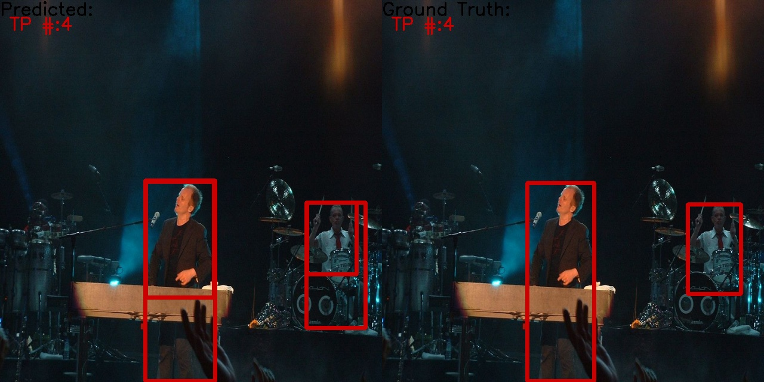

The model cannot see humans in long distance or with bad lighting if humans are not in crowd:

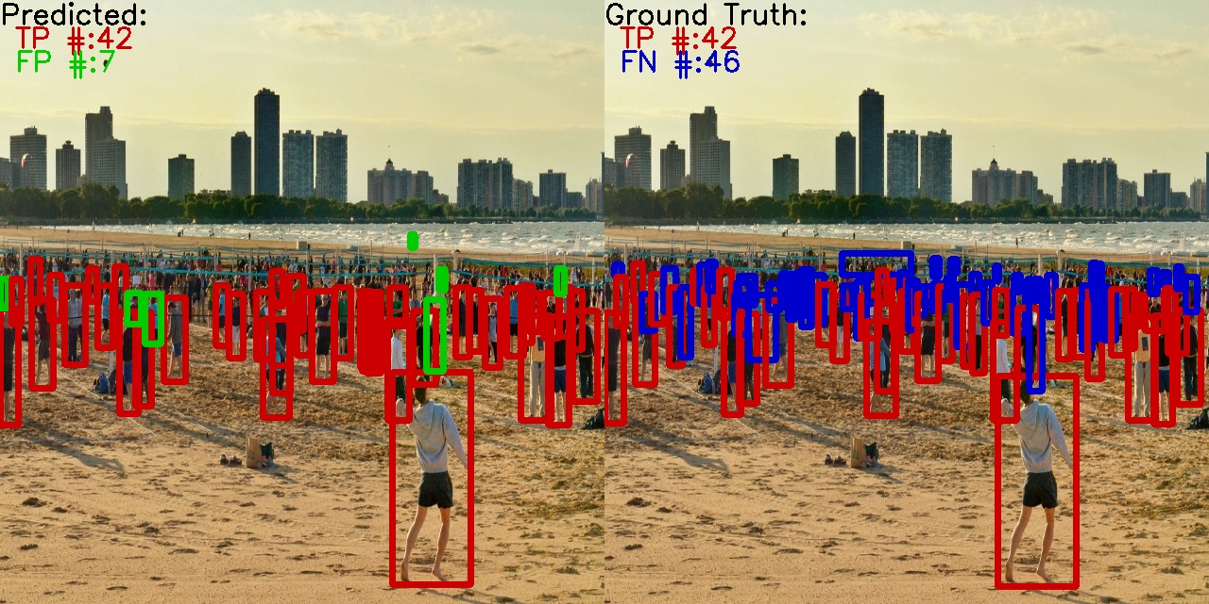

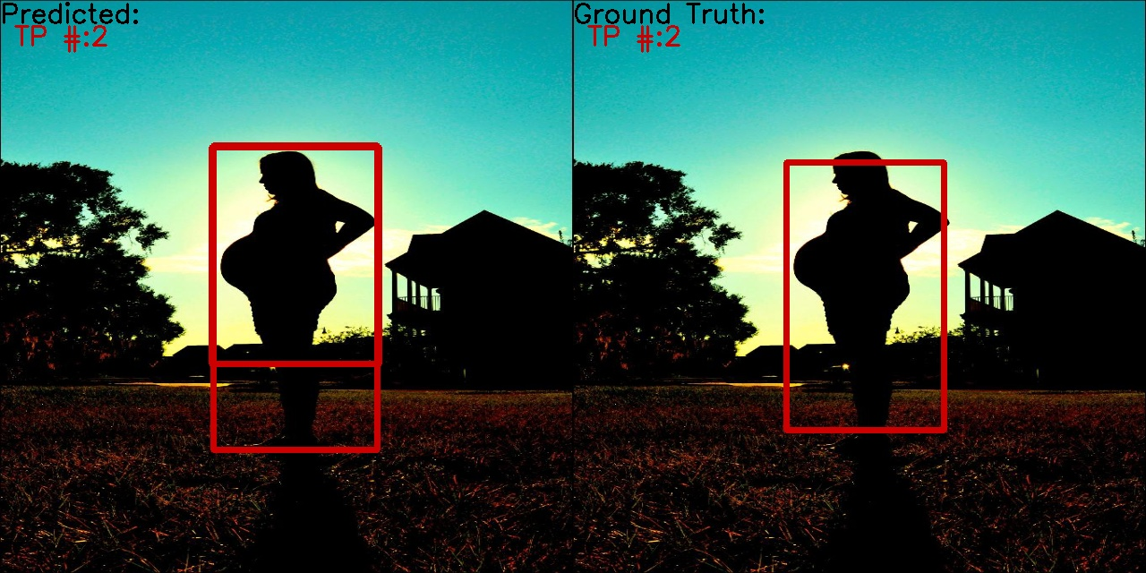

The model can detect humans in raining

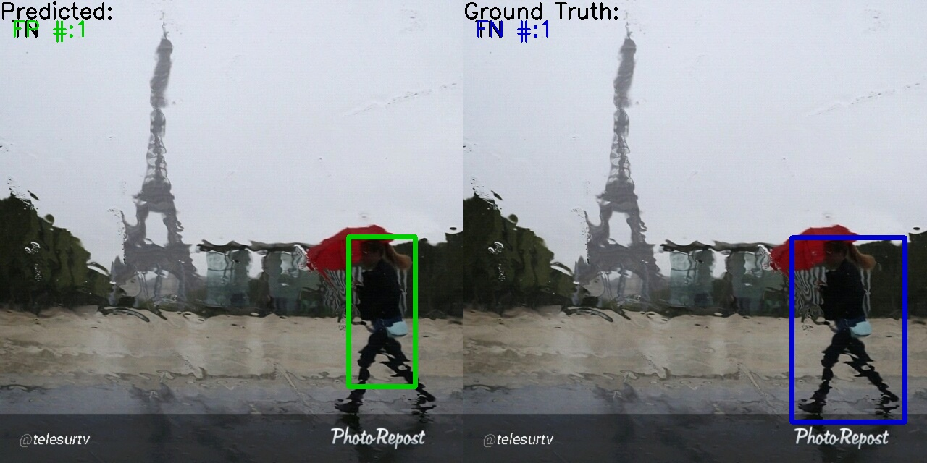

**Conclusion**

Difficult to differentiate some previously already annotated images. The model is more likely to classify each person in a crowd in comparison to average models. Mostly, the algorithm could greatly classify images. The model can confuse statues, background images, human shadows, animals, cartoons, dolls as humans. Due to a large distance between the crowd and human, bad lighting or obstacle, the model can classify crowd as one human. The model has difficulty to differentiate black men with black clothes. Due to obstacles, the model can label one human 2 times